Report for Web Authoring Assignment 2

Develop a website using HTML, CSS and JavaScript

Contents

HTML Markup and Cascading Style Sheets 1

File Formats 2

Image & Text Processing 2

Multimedia Files 2

Symbols & Characters 2

Scripting Elements in Web Authoring 2

JavaScript 2

Web Production 2

Navigation 3

Layouts & Design 3

SEO 3

Colour 3

Text / Fonts 3

Website Checking 3

Bibliography 3

# HTML Markup and Cascading Style Sheets

## File Formats

JPEG (Joint Photographic Experts Group) and PNG (Portable Network Graphics) are two popular image formats used on websites; each has advantages and disadvantages.

PNG images are lossless and uncompressed, which means that when they are compressed, no image data is lost. They are perfect for photographs with a transparent background or overlay because they also enable transparency. They are less suitable for photos that need to load rapidly on a web page because of their uncompressed nature and bigger file sizes. Images that must preserve their high quality, like logos or designs with text, are best suited for PNG images.

JPEG images, on the other hand, are lossy and compressed, which means that during compression, some image data is lost. Smaller file sizes because of compression make them better suited for websites where loading time is crucial. However, there is a chance that the image quality will suffer due to this compression. JPEG images work well for complicated or photographic images where a small amount of quality loss is acceptable and file size is an issue.

In conclusion, JPEG images are better suitable for complicated photos or photographs that need to load rapidly on a web page, whereas PNG images are best suited for images that require transparency or high quality, such as logos.(Adobe)

## Image & Text Processing

For my website, when you first hit the home page you will see my brand logo and the navigation menu and a very big slideshow show-casing all the different Microsoft Office products. This way as soon as my website visitor goes on my website, they will know for sure what this website is about, Microsoft Office products. I have also made my logo transform, so when a person hovers over my logo the text will expand.

My theme is based around Microsoft Office products. I created my own theme by making an image that has Microsoft Office products and having it repeat throughout the background of the website. I changed the opacity to this website down to 30%, so that this way the theme is kept up but it's not too overbearing where you just see the full color logos of Microsoft Office products everywhere and is lighter on the eyes.

I have also added an image of the 365 logos in my products page for all the various 365 subscriptions, which can be also accessed straight from the homepage by pressing the shop now button so as soon as the customer sees all of the products that come with 365 on the slideshow and they like it they can go to the products page straight away not having to use the navigation. I also added a hit page counter to my product page where it tells people the number of times people have visited the product page just above my products section.

### Elements

|  |  |  |  |
| --- | --- | --- | --- |
| **Page** | **Paragraphs** | **Links** | **Headings** |
| Home | 2 | 8 | 1 |
| Services | 1 | 7 | 1 |
| Products | 4 | 10 | 5 |
| 365 | 2 | 7 | 3 |
| About us | 1 | 6 | 2 |

#### Paragraphs

A paragraph is a block of text explaining a topic with an opening tag <p> and closing tag </p>. Here is an example from the about us page.

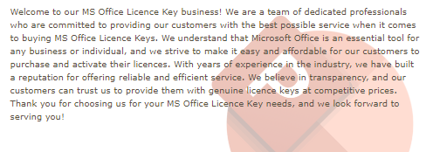

##### HTML

##### CSS

#### Links

Links are clickable text that either lead you to another webpage or open up a piece of content like a document. Links are written in html starting with the <a href=”example.html”> or <a href=”docs/example.pdf”> and are closed with an </a> tag at the end. Here is an example of a link I used from the download section of my “365” page.



##### HTML



##### CSS

#### Headings

A heading is used to title different parts of your page and is used to title those sections. It starts with <h#> tag with the # being the size of the heading ranging from 1-6 and ends with a </h#> tag to close the heading. Here is an example of the <h1> tag I used in my “365” page on my website.

##### HTML



##### CSS

#### Navbar

A navbar is used a menu bar that is used to navigate the website. It starts with <nav> tag and it closes with </nav> tag at the end. Here is an example of the navbar I did for my website that is seen on all pages.



##### HTML

##### CSS

## Multimedia Files

Both of my multimedia files can be found in my ‘About 365’ page of ‘MSOfficeInfo.html’.

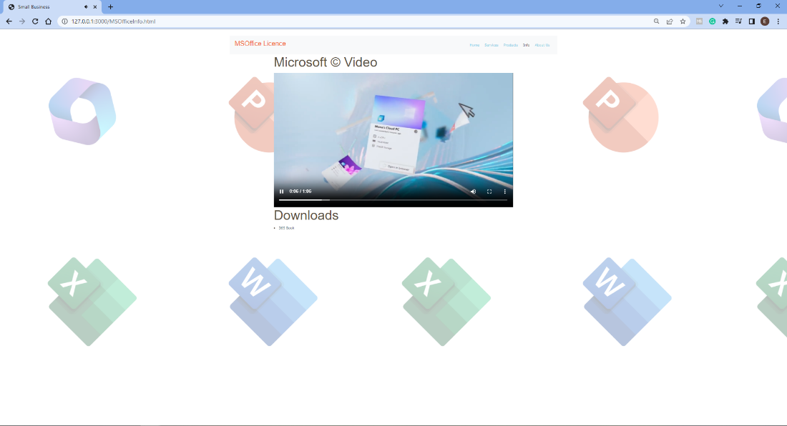

### The PDF link

For my PDF link I inserted a starting guide for ‘Office 365’ in my ‘Download Section’ in the ‘About 365’ webpage which you can find in ‘MSOfficeInfo.html’.



#### Code

<div class="col-md-8">

<h1>Downloads</h1>

<li><a href="365book.pdf">365 Book</a></li>

</div>

### Video

For my Video I inserted a trailer I found for ‘Office 365’ in my ‘Microsoft Video’ in the ‘About 365’ webpage which you can find in ‘MSOfficeInfo.html’.

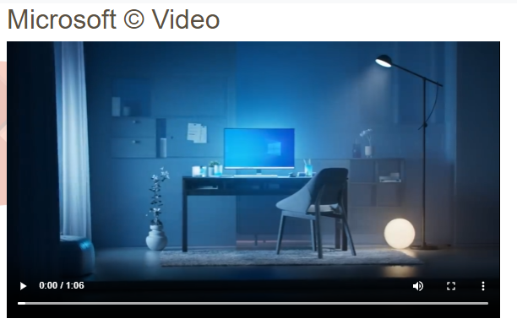

#### Code

<div class="col-md-8">

<h1>Microsoft &#169; Video</h1>

<div class="embed-responsive embed-responsive-16by9">

<iframe class="embed-responsive-item" src="images\msofficeinfo.mp4" autoplay="false"></iframe>

</div>

## Symbols & Characters

As one of the symbols I used the copyright symbol for any mention of ‘Microsoft’. To do this I would insert this code **&#169;** after any mention of ‘Microsoft’. As seen in the ‘Info’ page on my website or the ‘MSOfficeInfo.html’.

Another symbol that I used was a plane emoticon in my ‘Contact Form’ in the ‘Send’ button in my ‘About Us’ page. It is used by using this code in your html **&#9992;** you can find this in my ‘about.html’ webpage.

## Scripting Elements in Web Authoring

### **JavaScript**

#### Form Validation

I inserted a contact form with form verification in the “About Us” section. The customer must input an email before submitting their contact request. I did this using JavaScript in the ‘about.html’ webpage.

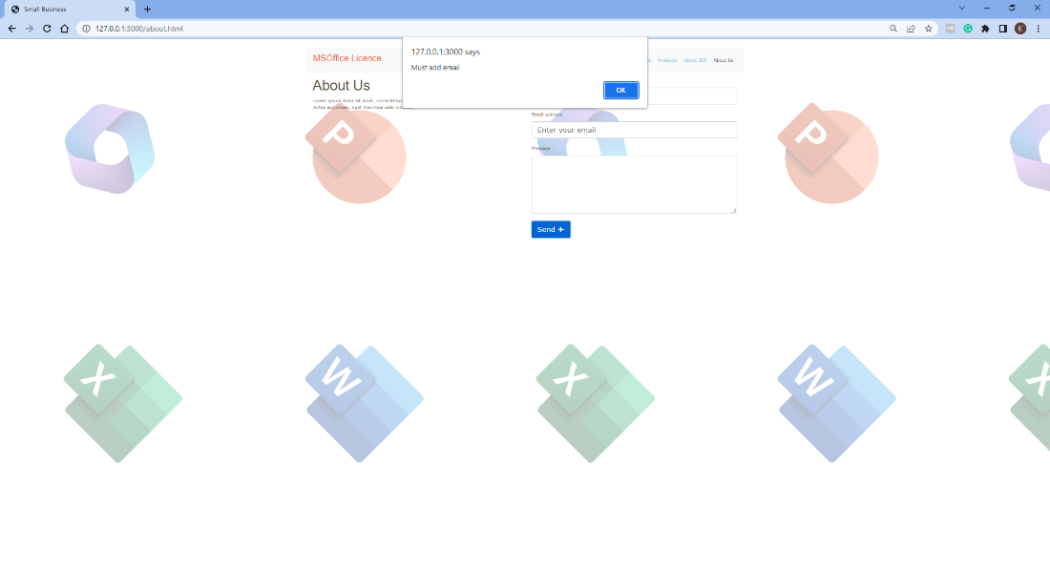

##### HTML

<div class="col-md-6">

<form name="myForm" onsubmit="return validateForm()" method="post">

<div class="form-group">

<label for="name">Name</label>

<input type="text" class="form-control" id="name" placeholder="Enter your name">

</div>

<div class="form-group">

<label for="email">Email address</label>

<input type="email" class="form-control" id="email" placeholder="Enter your email">

</div>

<div class="form-group">

<label for="message">Message</label>

<textarea class="form-control" id="message" rows="5"></textarea>

</div>

<button type="submit" class="btn btn-primary">Send &#9992;</button>

</form>

</div>

</div>

##### CSS

No custom CSS.

##### JS

function validateForm() {

let x = document.forms["myForm"]["email"].value;

if (x == "") {

alert("Must add email");

return false;

}

}

#### Slide Show

I added a JS slideshow on my Home/index.html page displaying various MS Office applications like excel, powerpoint and word.

[How it looks](https://cdetb-my.sharepoint.com/:i:/g/personal/22edvardaschvainickas_rathminescollege_ie/EYHWqmPtqblDo2dvprhu7BkBFPlQGBw8vy5IU2wHq-wYVA?email=mark.murtagh%40rc.cdetb.ie&e=mxUa8x)

##### HTML

<div class="container">

<div class="slideshow-container">

<div class="mySlides fade">

<div class="numbertext">365</div>

<img src="images\365.jpg" style="width:100%">

</div>

<div class="mySlides fade">

<div class="numbertext">Excel</div>

<img src="images\excel.jpg" style="width:100%">

</div>

<div class="mySlides fade">

<div class="numbertext">PowerPoint</div>

<img src="images\pp.jpg" style="width:100%">

</div>

<div class="mySlides fade">

<div class="numbertext">Word</div>

<img src="images\word.jpg" style="width:100%">

</div>

<br>

<div style="text-align:center">

<span class="dot"></span>

<span class="dot"></span>

<span class="dot"></span>

<span class="dot"></span>

</div>

##### CSS

/* Slideshow container */

.slideshow-container {

max-width: 1000px;

position: relative;

margin: auto;

}

/* The dots/bullets/indicators */

.dot {

height: 15px;

width: 15px;

margin: 0 2px;

background-color: #bbb;

border-radius: 50%;

display: inline-block;

transition: background-color 0.6s ease;

}

/* Fading animation */

.fade {

animation-name: fade;

animation-duration: 1.5s;

}

@keyframes fade {

from {

opacity: .4

}

to {

opacity: 1

}

}

/* On smaller screens, decrease text size */

@media only screen and (max-width: 300px) {

.text {

font-size: 11px

}

}

##### JS

let slideIndex = 0;

showSlides();

function showSlides() {

let i;

let slides = document.getElementsByClassName("mySlides");

let dots = document.getElementsByClassName("dot");

for (i = 0; i < slides.length; i++) {

slides[i].style.display = "none";

}

slideIndex++;

if (slideIndex > slides.length) { slideIndex = 1 }

for (i = 0; i < dots.length; i++) {

dots[i].className = dots[i].className.replace(" active", "");

}

slides[slideIndex - 1].style.display = "block";

dots[slideIndex - 1].className += " active";

setTimeout(showSlides, 2000); // Change image every 2 seconds

}

#### Status Bar

I added a JS status bar on my Home/index.html page that changes depending on the scroll position of the webpage.

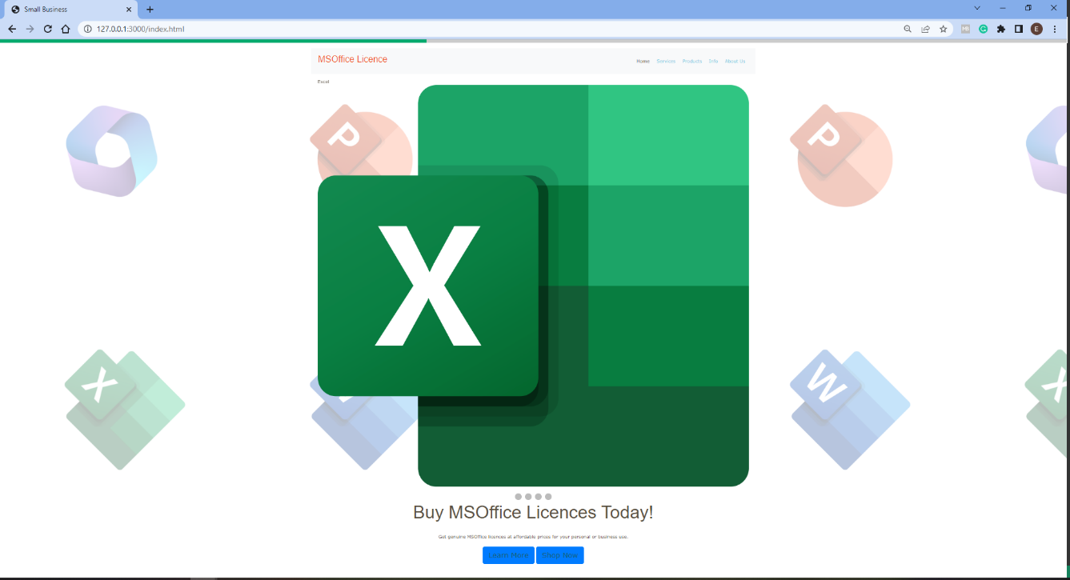

##### HTML Code

<div class="progress-container" bis_skin_checked="1">

<div class="progress-bar" id="myBar" bis_skin_checked="1" style="width: 25%;"></div>

</div>

##### CSS Code

.progress-container {

position: fixed;

top: 0;

z-index: 1;

width: 100%;

width: 100%;

height: 8px;

background: #ccc;

}

##### JS

window.onscroll = function () { myFunction() };

function myFunction() {

var winScroll = document.body.scrollTop || document.documentElement.scrollTop;

var height = document.documentElement.scrollHeight - document.documentElement.clientHeight;

var scrolled = (winScroll / height) * 100;

document.getElementById("myBar").style.width = scrolled + "%";

}

# Web Production

## **Navigation**

My navigation is at the top of the website for all pages. And has 5 sections. Home, Services, Products, About 365 and About Us as shown below



### HTML

In my code I have a comment **<!-- Navigation Bar with 5 links -->**. This is seen across all the pages with a navigation and looks like this with the code side by side.

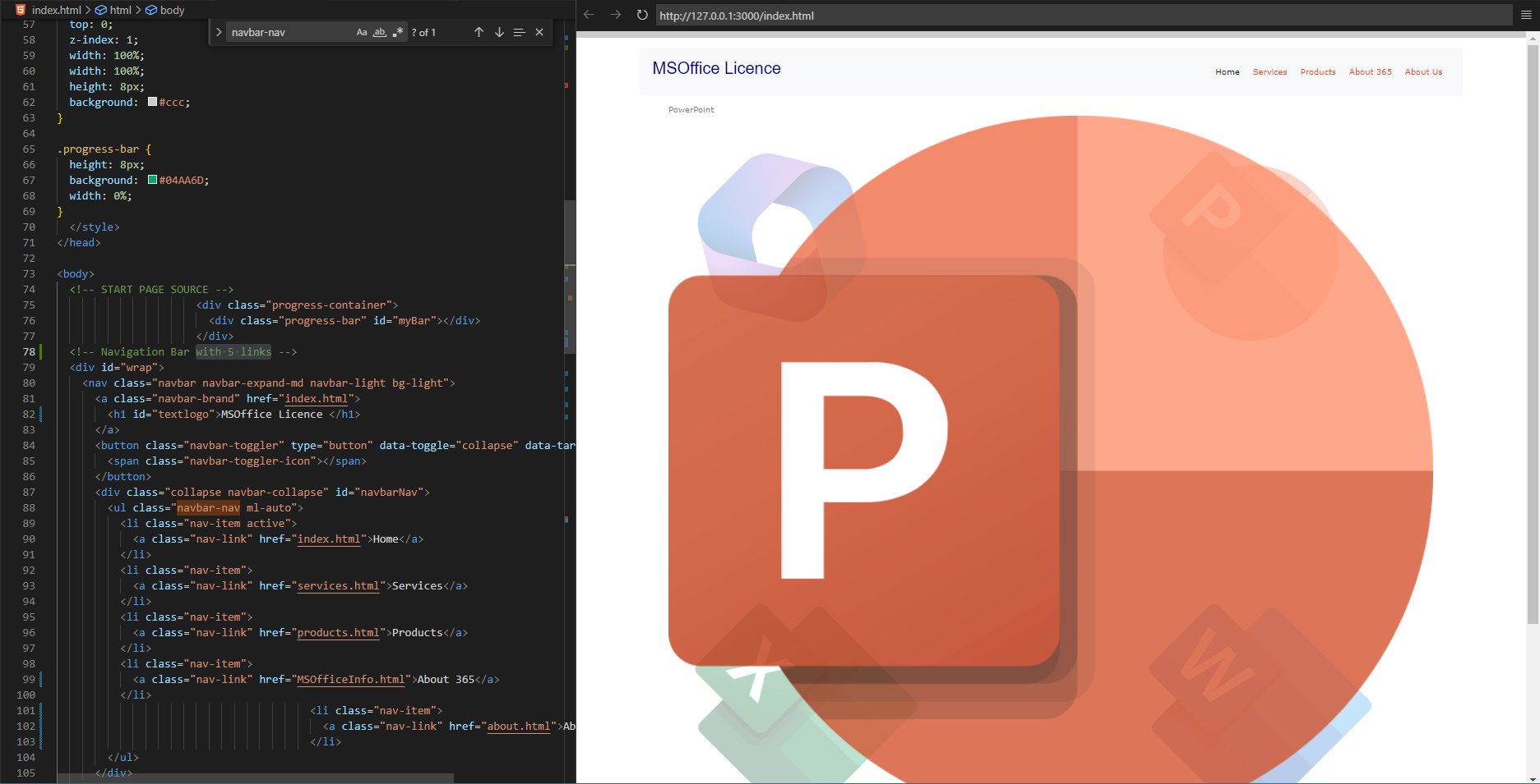

### CSS

In my code I have a comment explaining how the CSS afects the layout of my nav bar

**/* This is the CSS Styling of the Navbar. Automatic marging and padding at top to give a break from the top of the page */**

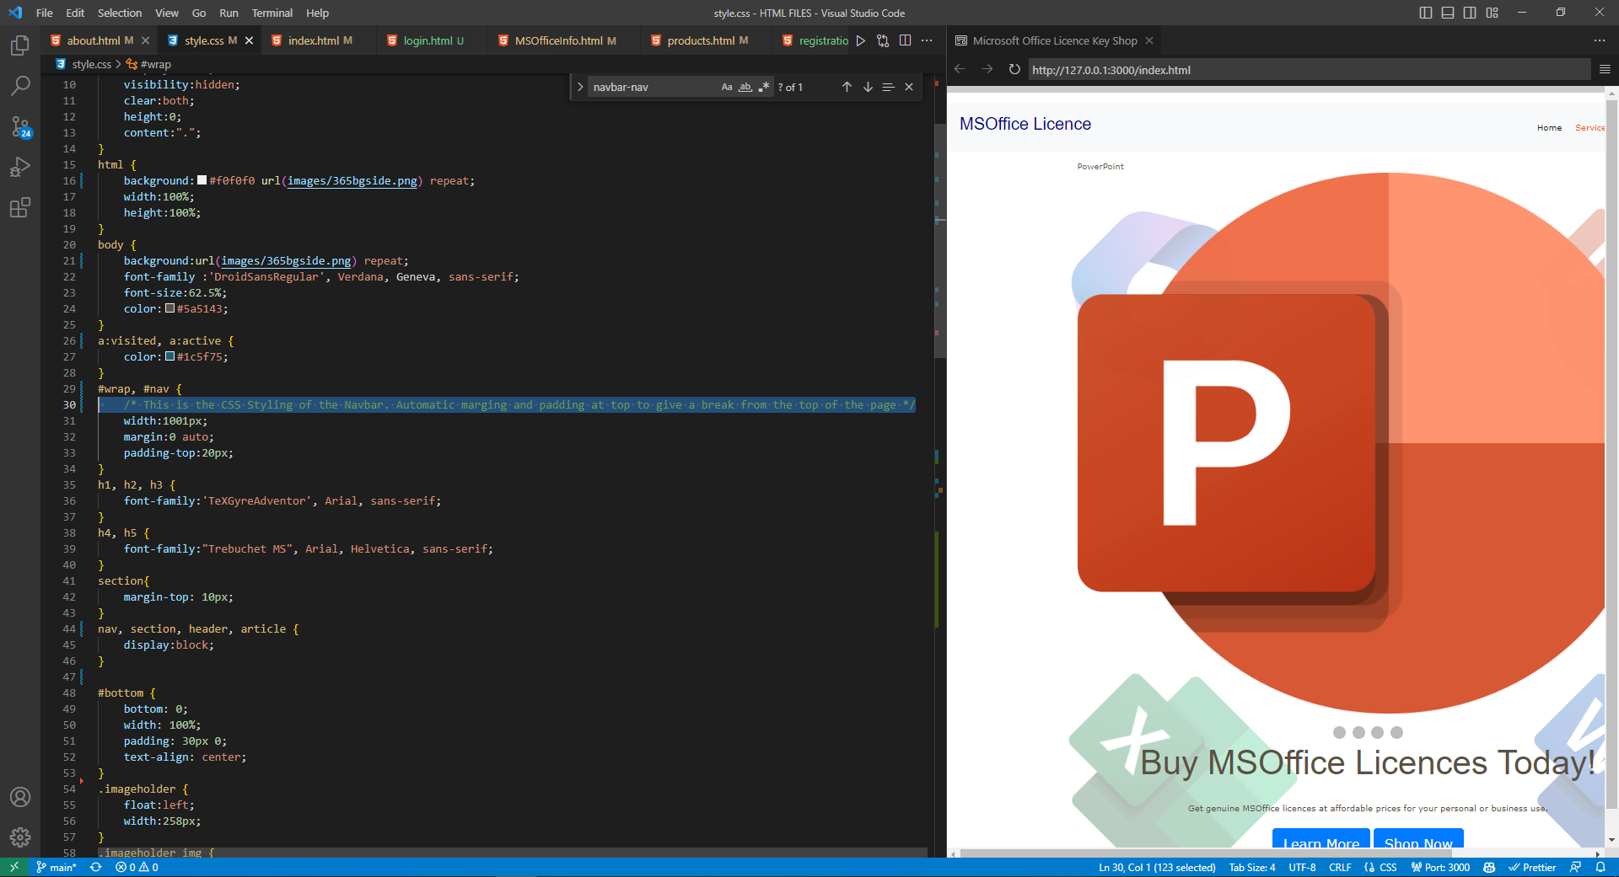

## Layouts & Design

For my website I used Bootstrap CSS which creates a responsive website and allows for great alignment between all of the different elements of the website. In terms of contrast and colour I used blue and orange which contrast well with each other and show people the importance of each link, with blue being the most important as that is the color of my logo. I’ve repeated this throughout my website.

|  |  |  |
| --- | --- | --- |
| **Principle** | **Definition** | **Applied in my site** |
| Contrast | Elements of the website contrast with each other depending on the function | My links are a different color to any other text on website |
| Alignment | All the elements are aligned in a tidy way | On my home page I’ve aligned the 2 buttons side-by-side and centred them |
| Colour | The colours of the website match the theme of website | I have used 3 colours throughout my website blue, orange and black |
| Consistency | The same style is applied throughout the website | I’ve used only one CSS file for my website and did the styling for all elements in there |
| Repetition | Elements of the website are in the same location on each page | My navigation bar is located on the top right of each page |

### Mobile

#### Wire Frame

#### Website

##### Chrome

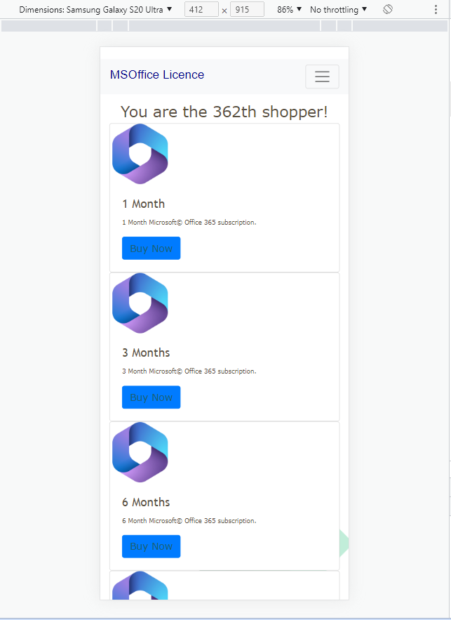

##### Firefox

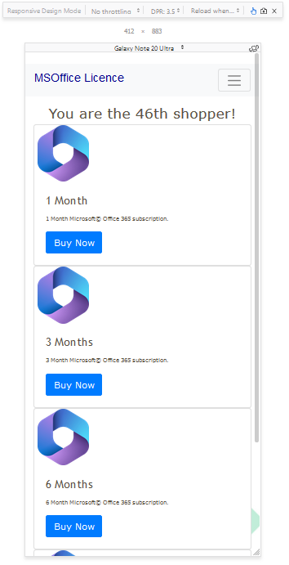

### Desktop

#### Wire Frame

Website

##### Chrome

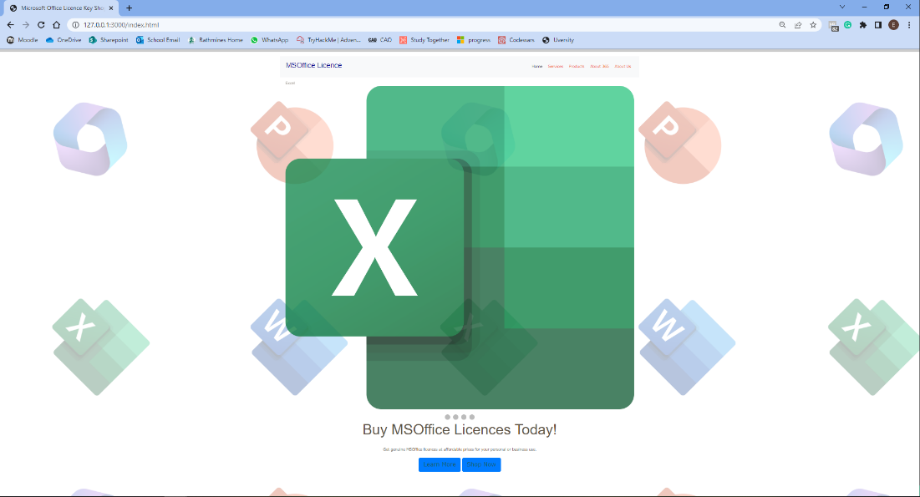

##### Firefox

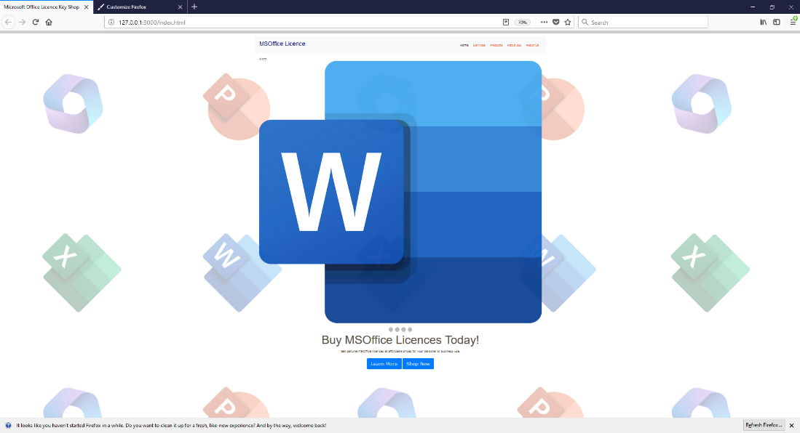

## SEO

To improve my SEO rating, I've changed the <title> tag and the meta name="description"> tag on two web pages I thought would most benefit from this.

### Home/index.html

#### <title>

**“Microsoft Office Licence Key Shop”**

I believe this is quite a good title for my shop. it is clear, it has the main keywords like Microsoft Office and license key. I believe if a customer is looking for Microsoft Office keys this will help me rank higher in search engines so they can find me faster.

#### <meta name="description">

**“Buy Microsoft Office Licence keys at a cheap price.”**

It is quite clear and concise and tells the customer exactly what we are selling. Also, if people are searching for cheap Microsoft Office keys in search engines our website should rank higher.

### Products Shop/products.html

#### <title>

**“MSOffice 365 Subscriptions”**

The title is clear and if a perso`` n is looking for a 365 subscription, they should be able to land on our page because we have this in our <title> tag.

#### <meta name="description">

**“This is a website that sells Microsoft Office Licence Keys with 1-month subscription,3-month subscription,6-month subscription,12-month subscription at great prices!”**

I believe this is a good meta description because it is very clear in that it explains what the shop sells and lists what we sell. It will be easy for the customer to know what the shop is about when they find us on search engines and if they are looking for a specific subscription we will also show up.

## **Colour**

For my website I used dark blue and orange as they are complementary of each other and have a big significance with Microsoft products, blue being the main color of Word and orange is the main color of PowerPoint. For my main logo I used dark blue because it signifies trust, dignity, intelligence and authority (Color Matters), this is the feel I want to put forward for my website because I am selling a tool that helps with productivity so I want this website 2 look like people can trust us and that they are smart if they use Office 365 products because it helps them with their productivity.

I use orange in other parts of my website like links and subheadings because it is a sharp color and mixed in with blue (Color Matters)is visually appealing.

For text on my pages I used black because it contrasts well with my theme background which is mainly white.

### CSS Code

**BLUE -** color: #00008B;

**ORANGE -** color: #F15524;

**BLACK -** color: black;

## Text / Fonts

MSOffice Licence

I used the ‘Verdana’, sans-serif font. Sans-serif fonts are used in modern logo more (Adobe) and the reason I chose ‘Verdana’ is because it is a web-safe font and is a very readable font (W3Schools)

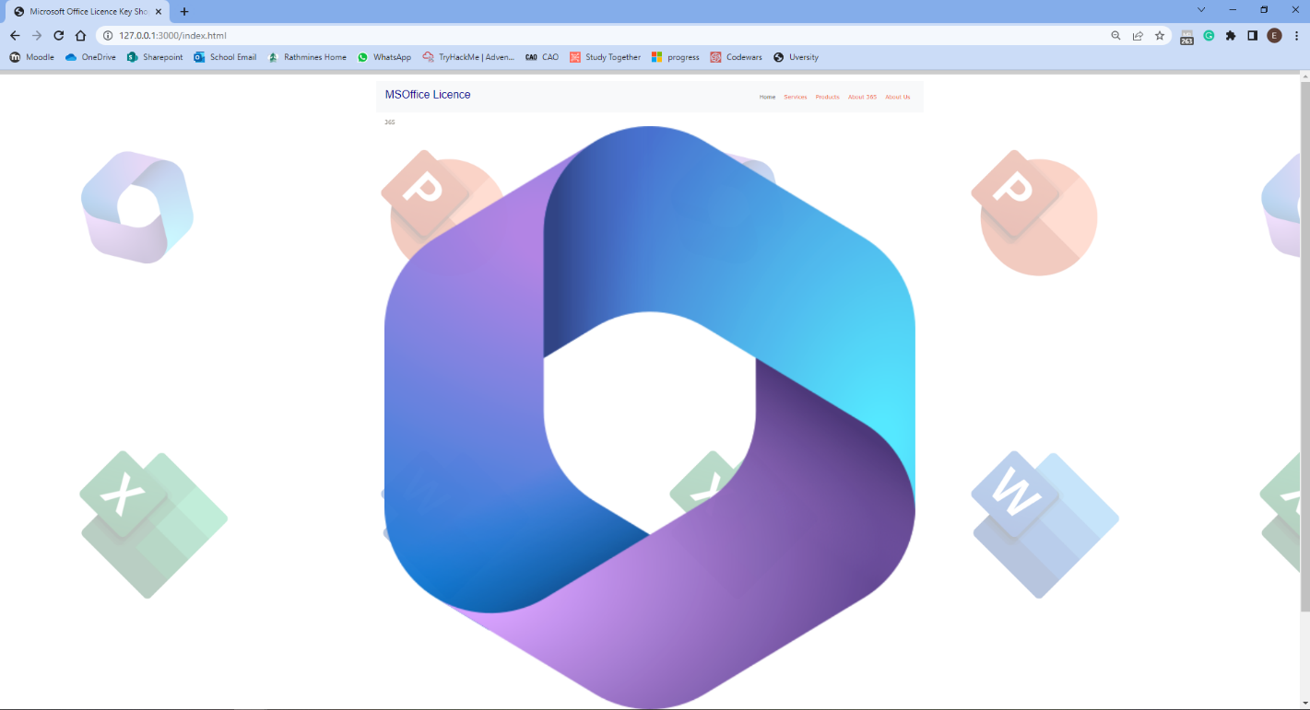

## Website Checking

To check my website I ran it through a code checker and debugger [https://validator.w3.org/](https://validator.w3.org/%20) for my HTML code and <https://jigsaw.w3.org/> for my CSS code. After running everything through the debuggers I was able to identify all the problem and solve them using the Debug Plans

### HTML Debug Plan

|  |  |
| --- | --- |
| Error | Solution |
| **Backslash ("\") used as path segment delimiter.** | I have changed the path segment delimeter to a forward slash ("/") |
| **An img element must have an alt attribute, except under certain conditions. For details, consult guidance on providing text alternatives for images.** | I will need to run through each image and put appropriate alt tags |
| **End tag** section **seen, but there were open elements.** | I closed all the open elements |
| **Unclosed element** div**.** | I’ve went through my code and closed all of the open divs |

Index.html

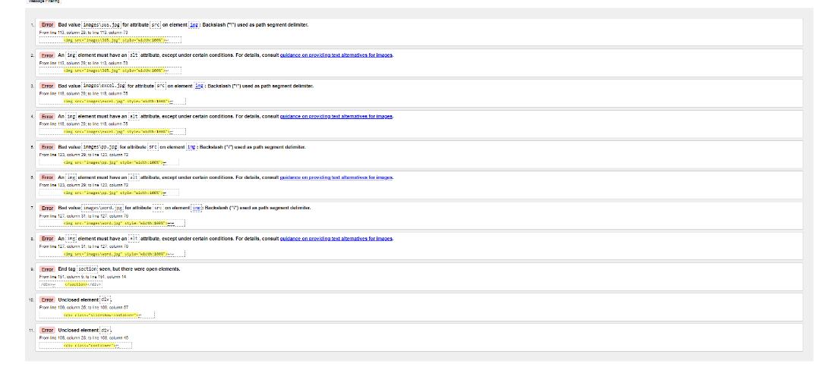

About.html

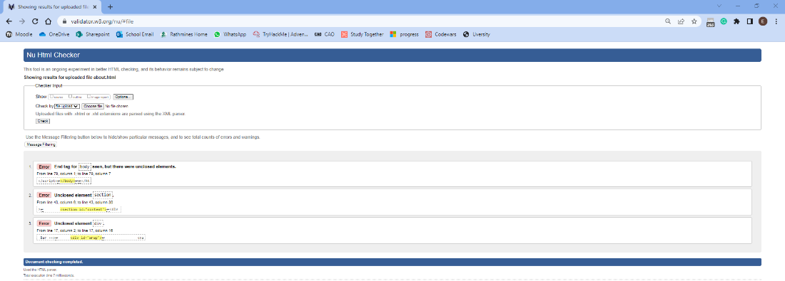

MSOfficeInfo.html

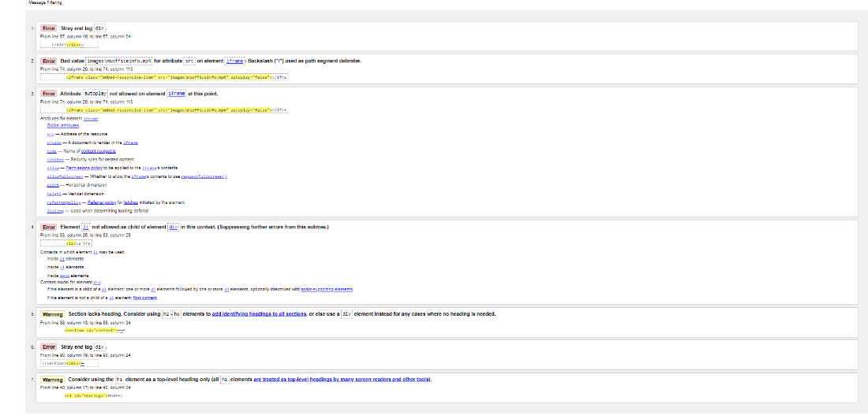

Products.html

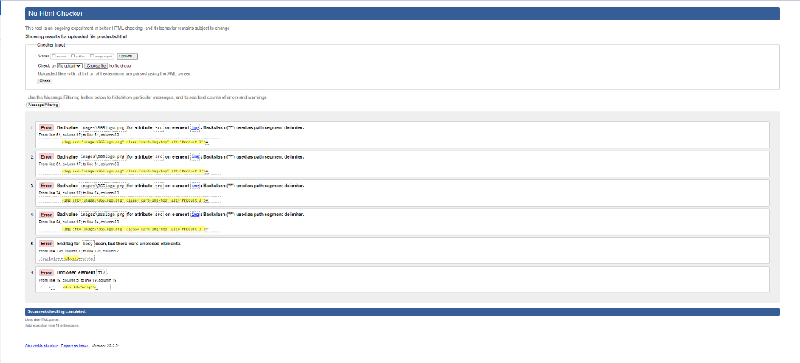

services.html

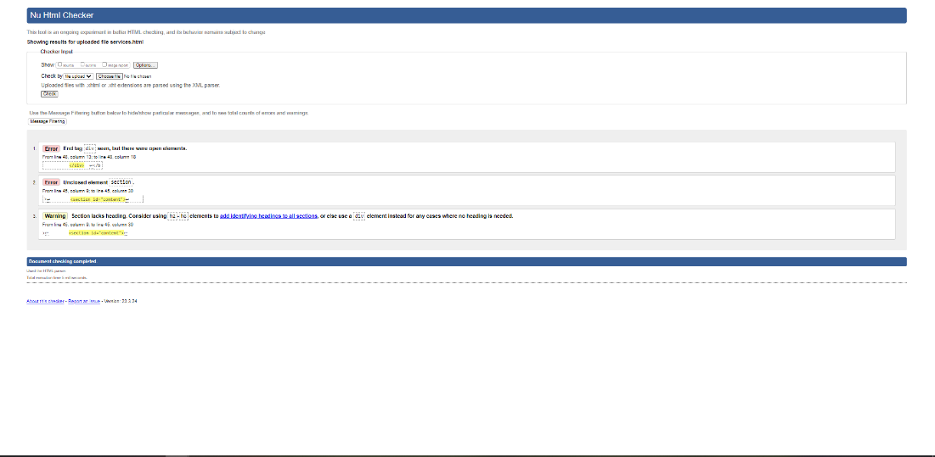

### CSS Debug Plan

|  |  |
| --- | --- |
| Error | Solution |
| **Value Error : font verdana is not a font value : verdana** | Remove the value verdana for font |
| **Property responsive doesn't exist : true** | Remove this property |

Style.css



# Bibliography

Adobe. (n.d.). *JPEG vs. PNG.* Retrieved from Adobe.com: (https://www.adobe.com/ie/creativecloud/file-types/image/comparison/jpeg-vs-png.html#:~:text=Because%20of%20their%20different%20compression,them%20preferred%20for%20graphic%20design.)

Adobe. (n.d.). *The Best Logo Fonts and How to Choose Your Own.* Retrieved from https://www.adobe.com: https://www.adobe.com/express/learn/blog/best-logos-for-brand

Color Matters. (n.d.). *The Meanings of Blue.* Retrieved from https://www.colormatters.com/: https://www.colormatters.com/the-meanings-of-colors/blue

Color Matters. (n.d.). *The Meanings of Orange.* Retrieved from https://www.colormatters.com: https://www.colormatters.com/the-meanings-of-colors/orange

Hunt, T. (2019, October 21). *A Pro Designer Shares the Psychology of Font Choices*. Retrieved from The Daily Egg: https://www.crazyegg.com/blog/psychology-of-fonts-infographic/

W3Schools. (n.d.). *CSS Web Safe Fonts.* Retrieved from https://www.w3schools.com/: https://www.w3schools.com/cssref/css_websafe_fonts.php